Declaration of Conformity (DoC)

We, Shenzhen Doke Electronic Co., LTD

801, Building3, 7th Industrial Zone, Yulv Community, Yutang Road, Guangming District,
Shenzhen, China

Declare that the DoC is issued under our sole responsibility and belongs to the following product(s):

Product Type: | Smart tablet
Brand Name | Blackview
Model Number(s): | LINK Mini Kids
Hardware Version: | /
Software version: | /

(Name of product, type or model, batch or serial number)

System components:

PIFA antenna;
Antenna Gain:
BT/Wi-Fi2.4G: 0.8dBi;
WIFI5G: 1.2dBi;

Adapter:
Model:QZ-01004EA00
Brand: Blackview
Input: 100-240V~50/60Hz 0.3A
Output: DC5.0V 2.0A 10.0W
Manufacturer: Quanzhi Guangdong Technology Co., Ltd.

Rechargeable Li-ion Battery:
Model: U317296PVUTL
Specification: 3.8V, 3000mAh, 11.4Wh
Manufacturer: SHENZHEN UTILITY ENERGY CO., LTD.

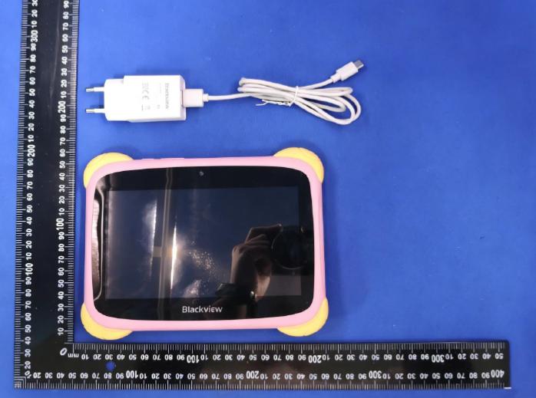
The object of the declaration described above is in conformity with the essential requirements of

the relevant Union harmonization legislation: Radio Equipment Directive RED (2014/53/EU). The following harmonized standards and technical specifications have been applied: HEALTH & SAFETY (Art. 3(1)(a)):
EN 50566:2017+A1:2023
EN IEC/IEEE 62209-1528:2021
EN 50663:2017
EN 62479:2010

EN IEC 62368-1:2020+A11:2020

EMC (Art. 3(1)(b)):

ETSI EN 301 489-1 V2.2.3 (2019-11)
ETSI EN 301 489-3 V2.3.2 (2023-01)
ETSI EN 301 489-17 V3.3.1 (2024-09)
EN 55032:2015+A11:2020
EN 55035:2017+A11:2020
EN IEC 61000-3-2:2019+A2:2024
EN 61000-3-3:2013+A2:2021+AC:2022

Radio Spectrum (Article 3.2):

ETSI EN 300 328 V2.2.2 (2019-07)
ETSI EN 301 893 V2.1.1 (2017-05)
ETSI EN 300 440 V2.2.1 (2018-07)

The submitted samples of the above equipment has been tested and found to comply with the following European Directives:
RoHS Directive 2011/65/EU & (EU) 2015/863

NOTIFIEDBODY:

Name: LGAl Technological Center S.A. (APPLUS)

Address: Campus UAB. Ronda de la Font del Carme s/n08193 Bellaterra, Barcelona (Spain)

Notified Body No. 0370

EU-type examination certificate number: No. 0370-RED-11558

RF Specification:

Function | OperationFrequency | Max RF output power:
BLE | 2402MHz–2480MHz | 2.42dBm
BT(BR+EDR) | 2402MHz–2480MHz | 2.50dBm
WIFI 802.11b/g/  n(HT20/40)/ ax(HE20/40) | 802.11b/g/n(20MHz)/ax(20MHz):2412~2472MHz;  802.11n(40MHz)/ax(40MHz):2422~2462MHz | 13.80dBm
Wi-Fi  5.2G(802.11a/n20/n40/ac2  0/ac40/ax20/ax40 | 802.11a/n20/ac20/ ax20:5180MHz~5240MHz  802.11 n40/ac40/ax40:5190MHz~5230MHz | 13.90dBm
Wi-Fi  5.8G(802.11a/n20/n40/ac2  0/ac40/ax20/ax40 | 802.11a/n20/ac20/ax20:5745MHz~5825MHz  802.11n40/ac40/ax20:5755MHz~5795MHz | 13.59dBm

Tests for SAR are conducted using standard operating positions with the device transmitting at its

highest certified power level in all tested frequency bands. The maximum SAR values tested on this device when used in its normal position at the ear and when used closet othe body(at a minimum distance of 5mm/0mm) are:

Max SAR Value(W/kg) Limitis 2.0(W/kg) for10-g | Body | 0.174W/kg
Max SAR Value(W/kg) Limitis 4.0(W/kg) for10-g | Member DAS | 0.174W/kg

Technical file held by: Shenzhen Doke Electronic Co., LTD
Address: 801, Building3, 7th Industrial Zone, Yulv Community, Yutang Road, Guangming District, Shenzhen, China
Signed for and on behalf of: Shenzhen Doke Electronic Co., LTD

Name and Title: | Hong zongqing / Manager
Address: | 801, Building3, 7th Industrial Zone, Yulv Community, Yutang Road, Guangming District, Shenzhen, China



Signature of Authorized Person
2026-05-08

